HAZCOM Program Administrator: ________________________________

Policy
Our company is committed to the prevention of exposures that result in injury and/or illness; and to comply with all applicable state health and safety rules. To make sure that all affected employees know about information concerning the dangers of all hazardous chemicals used, the following hazard communication program has been established.
All employees of our company will participate in the hazard communication program. This written program will be available in the main company office or the Maintenance Shop bookshelf for review by any interested employee.
The administration of this program will be the responsibility of the HAZCOM Program Administrator. The administrative responsibilities of this individual/position will include:
1. Identification of the employees to be included in the Hazard Communication Program.
2. Development and maintenance of a hazardous substance master inventory.
3. Coordination and supervision of employee training.
4. Coordination and supervision of the facility's container labeling program.
5. Coordination of any necessary exposure monitoring.
6. Coordination and supervision of required recordkeeping.
7. Periodic evaluation of the overall program.
Employees are responsible for following all safe work practices and using proper precautions required by the guidelines in this program

Container Labeling
The HAZCOM Program Administrator is responsible for container labeling procedures, reviewing, and updating. The labeling system used is as follows:
- Manufacturer labels should be kept on all containers.
- Non-original containers must also have GHS Compliant labels that represent the chemical hazards affixed to them.
Administrator can label new containers with GHS compliant labels by:
- using and buying a smaller container with the manufacturers original label or
- by taking a picture of the original label and affixing it to the new container
Some chemicals, like corrosives, cannot be used in non-original containers.

Material Safety Data Sheets (MSDS) or Safety Data Sheets (SDS)
It is the responsibility of the HAZCOM Program Administrator to establish and monitor the SDS program. The Program Administrator will make sure procedures are developed to obtain the necessary MSDS or SDSs and will review incoming MSDS or SDSs for new or significant health and safety information. This person will see that any new information is passed on to all employees.
The procedures to obtain SDSs and review incoming SDSs for new or significant health and safety information are as follows:
Download a pdf copy of SDS from the manufacturers website and save in onto our company Server under HAZCOM – SDS file.
Ask retail stores to provide MSDS or SDS sheets for all chemicals. Scan a copy to our company office to be added to our HAZCOM – SDS file.
Chemicals with existing MSDS should be updated every 3-5 years. (MSDS sheets are being phased out.)
Copies of MSDS or SDSs for all hazardous chemicals in use will be kept in the company office for 7 years after product use.
MSDS or SDS will be available by request to all employees. If an SDS or MSDS is not available or a new chemical in use does not have an MSDS, immediately contact the HAZCOM Program Manager.
Note: If an alternative to printed Material Safety Data Sheets is used (such as computer data), provide a description of the format. PDFs of SDS Sheets are stored on our company server under file folder “SDS Sheets”.

Hazardous Non-Routine Tasks
Prior to starting work on such projects, each affected employee will be given information by the supervisor about the hazardous chemicals they may encounter during these activities:
• _____________________________________
• _____________________________________

Multi-Employer Work Places
It is the responsibility of our company to provide other employers or sub-contractors with employees at the facility with the following information:
Copies of SDS or MSDSs (or make them available at a central location) for any hazardous chemicals that the other employer(s)’ employee may be exposed to while working.
Inform other employers of any precautionary measures that need to be taken to protect employees during normal operating conditions or in foreseeable emergencies.
Provide other employers with an explanation of the labeling system that is used at the facility.
It is also the responsibility of our supervisors to identify and obtain MSDSs for the chemicals the other contractor is bringing into the work place.

Emergency Response Procedures for Hazardous Chemical Spills
When a hazardous chemical spill occurs, follow these procedures:
1. Move all employees away from spill to a safe environment.
2. Call 911 or the designated emergency response number in your area to notify the necessary response team for the hazardous chemical spill.
3. Retrieve the Hazard Communication Information Binder or SDS from server, if possible. Locate the MSDS for the hazardous chemical which spilled.
4. If proper cleanup equipment, monitoring devices, and PPE are available, proceed with cleanup.
5. If proper cleanup equipment, monitoring devices, and PPE ARE NOT available, call 911 and request a HAZMAT EMERGENCY RESPONSE TEAM.
Note: Do not try to contain the spill if you do not have proper equipment. The Emergency or Hazardous Material Response Team is trained to deal with hazardous chemical spills.

Employee Information and Training WAC 296-901-14016
The HAZCOM Program Administrator is responsible for the employer/employee training program. The procedures for how employees will be informed and trained are as follows:
Employees will be trained yearly on the company hazard communication program and individually if non-routine tasks apply.
The Program Administrator will make sure that before starting work, each new employee of our company will attend a health and safety orientation that includes information and training on the following:
- An overview of requirements contained in the hazard communication standard.
- Hazardous chemicals present at his or her work places.
- Location of the SDS and MSDS file and written Hazard Communication program.
- Employees will read the health hazards and PPE requirements for most common chemicals used.
- Pictogram meanings.
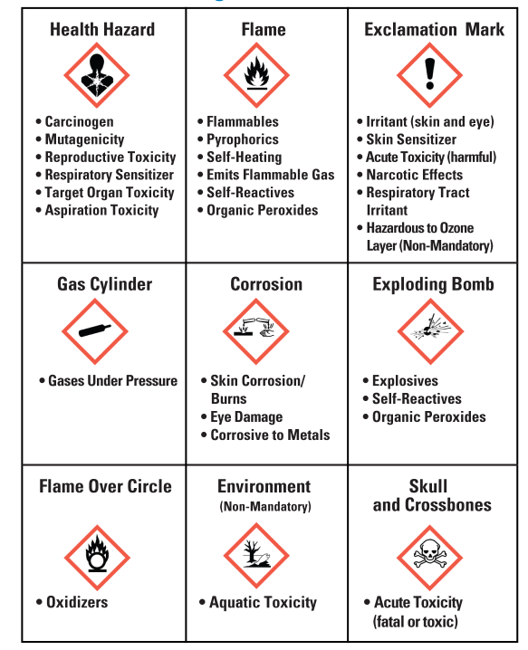
The introduction of new chemicals not used before will require additional training for employees.

List of Hazardous Chemicals:
The following is a list of all known hazardous chemicals used by our employees. Further information on each chemical may be obtained by reviewing SDSs located on the company server or at the company Main Office.
Give each product a company number. Find the online SDS and hyperlink the product name to the online SDS. Download a PDF copy and save to server under “SDS”. Review products for safety and heath hazards. Make additional lists or books if necessary.
company Number | Product Name (add hyperlink) | Quantity | Use | Pictograms | PPE Required
1
2
3
4
5
6
7
8
9
10
11
12
13
14
15
16
17
18
19
20
21

Make additional lists or books if necessary.
Use this key for pictograms (HH) Health Hazards (XX) Toxic (!) Exclamation mark, (EB) Explosive, (F) Flammable, (G) Gas Cylinder, (C) Corrosive, (FC) Oxidizer, (EN) Environmental Hazard.

